“Kyiv specialized College of Communications”

Commission of computer engineering

**PERFORMANCE REPORT**

**WORK-CASE №4**

From the discipline: "Operating systems"

The students

   performed Groups RPZ-03

Team 3: Kanavets K.S.,

Kryvenko A.I.,

Kulikovska M.V.

Checked by the teacher

                                                   Sushanova V.S.

The material was prepared by student Andrew Kryvenko (@AndrewKryvenko)

Consider the following questions and answer them:

**1. When working with a personal computer, it is often necessary to connect peripheral equipment. Using the example of a printer and a flash drive, describe what mechanism Linux has for working with them.**

**- What is the essence of the mount operation, what is it used for, and how?**

**- What is the difference between working with peripherals in Linux and Windows?**

When you work with a personal computer, connecting peripherals such as a printer or flash drive is a routine process. In Linux, this process is accomplished by using the mount mechanism, which allows you to change the relationship between the file system and the peripheral device.

The mount operation involves connecting an external device to the computer and creating a link between the OS file system and the device to allow access to files on the device through the file system. When you connect the device, Linux automatically recognizes the device and creates a directory in the /media or /mnt folder that contains the files stored on the device.

In Windows, external devices are also connected using the mount mechanism. However, in Windows, this operation can be more complicated because drivers and other software components need to be installed for different devices.

The material was prepared by student Kulikovska Maria (@Smith5004)

**2. Connect a USB flash drive and a printer (if possible) to your virtual machine with Linux installed, and use the graphical interface to copy one file from the flash drive to the virtual machine and print it (repeat the same steps, but with another file and using commands in the terminal).**

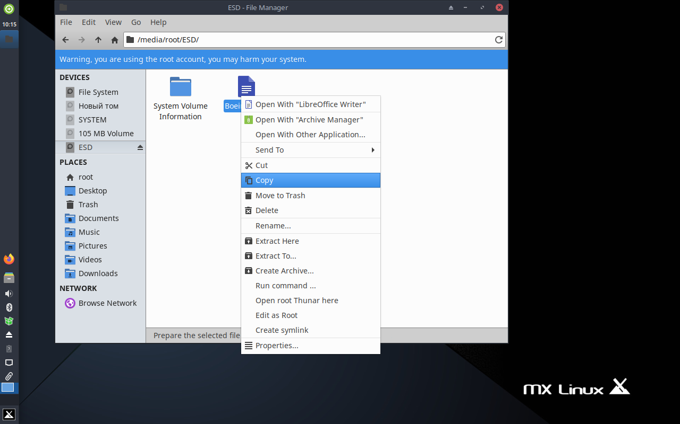

To copy files in Linux through the terminal, use the command: cp.

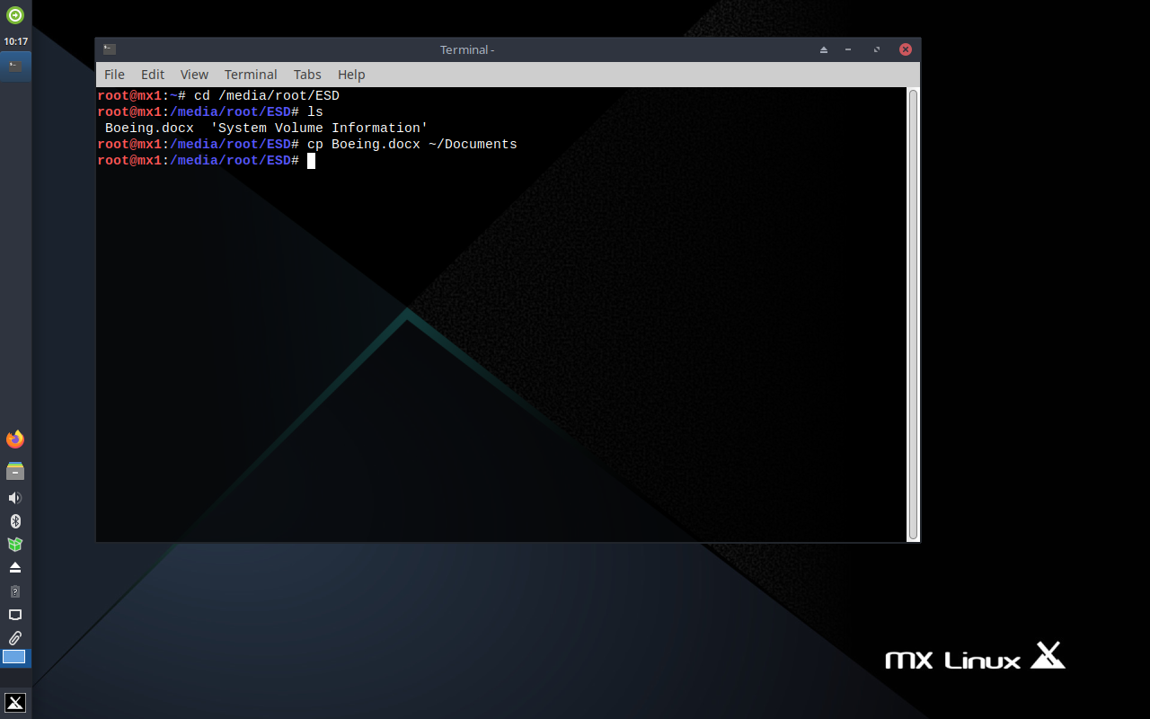

To print a file, you need to configure the printer and download the necessary drivers.

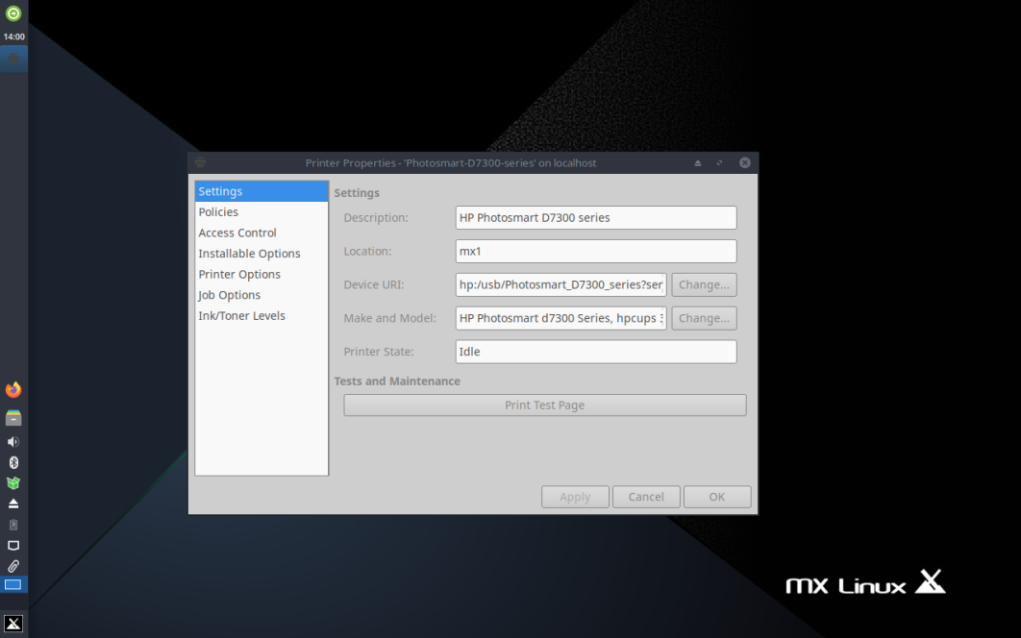

To print a file through a graphical interface, we can use a common Linux text editor - LibreOffice Writer.

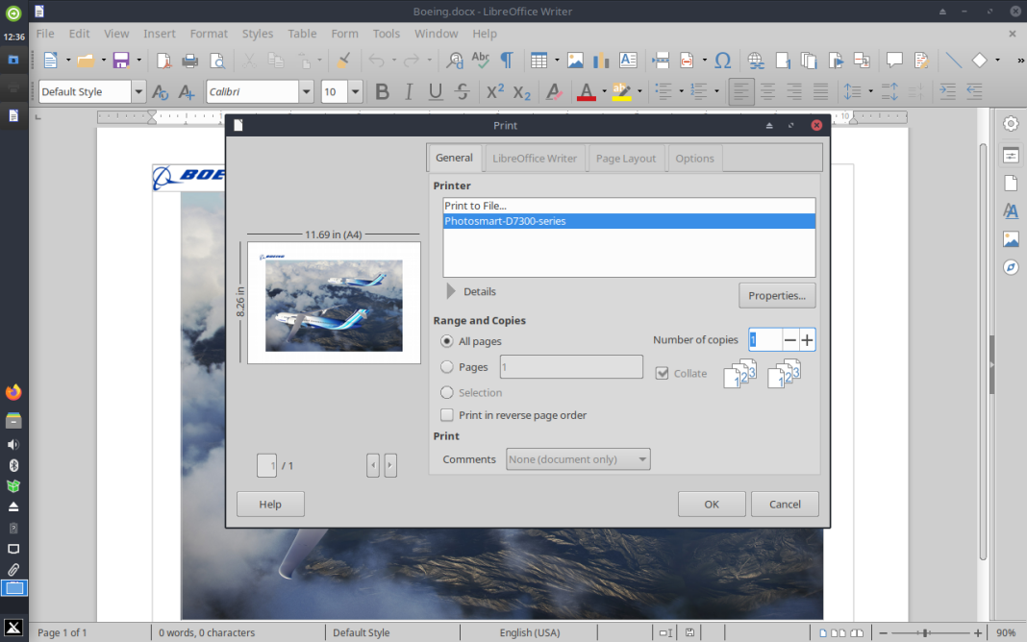

To display a list of connected printers, run the command: lpstat -p -d .

The above command will display a list of available printers. The "-p" option is used to display a list of printers, and the "-d" option specifies the default printer.

To print a file from the terminal, use the command: lpr.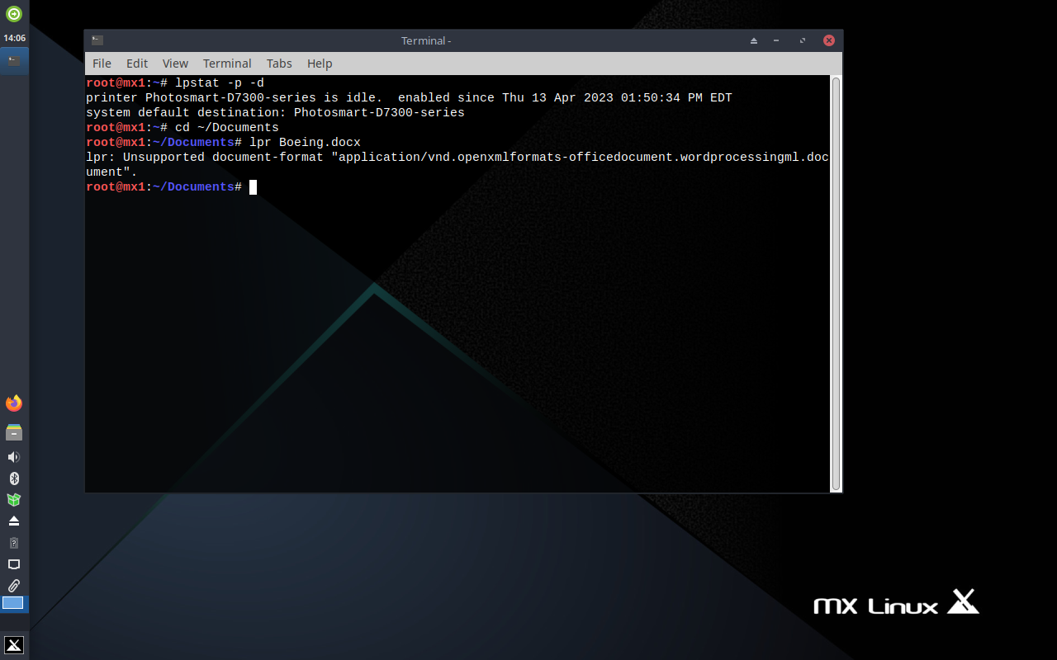

3.The report, translation and result of work in the git was made by student Kanavets Kateryna

(@kanavetsk)